In this video we will discuss how to use bearer token for authentication and retrieving data from the server. This is continuation to [Part 24](http://csharp-video-tutorials.blogspot.com/2016/12/aspnet-web-api-login-page.html). Please watch [Part 24](http://csharp-video-tutorials.blogspot.com/2016/12/aspnet-web-api-login-page.html) from [ASP.NET Web API tutorial](https://www.youtube.com/playlist?list=PL6n9fhu94yhW7yoUOGNOfHurUE6bpOO2b) before proceeding.  
  
We want to implement a page that retrieves employee data from the server. If the user is not authenticated, he should be automatically redirected to the login page. The user should be able to get to the data page, only if he is logged in.   
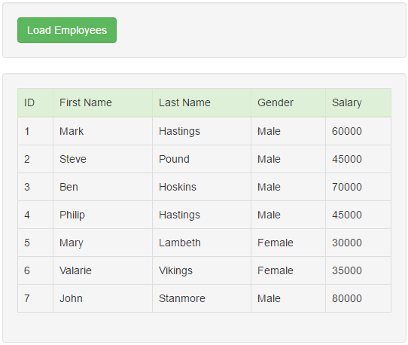   
  
  
  
Add a new HTML page to the **EmployeeService**project. Name it **Data.html** page. Copy and paste the following HTML and jQuery code. 

<!DOCTYPE html>

<html>

<head>

    <title></title>

    <meta charset="utf-8" />

    <link href="Content/bootstrap.min.css" rel="stylesheet" />

</head>

<body style="padding-top:20px">

    <div class="col-md-10 col-md-offset-1">

        <div class="well">

            <input id="btnLoadEmployees" class="btn btn-success"

                   type="button" value="Load Employees" />

        </div>

        <div id="divData" class="well hidden">

            <table class="table table-bordered" id="tblData">

                <thead>

                    <tr class="success">

                        <td>ID</td>

                        <td>First Name</td>

                        <td>Last Name</td>

                        <td>Gender</td>

                        <td>Salary</td>

                    </tr>

                </thead>

                <tbody id="tblBody"></tbody>

            </table>

        </div>

        <div class="modal fade" tabindex="-1" id="errorModal"

             data-keyboard="false" data-backdrop="static">

            <div class="modal-dialog modal-sm">

                <div class="modal-content">

                    <div class="modal-header">

                        <button type="button" class="close" data-dismiss="modal">

                            &times;

                        </button>

                        <h4 class="modal-title">Session Expired</h4>

                    </div>

                    <div class="modal-body">

                        <form>

                            <h2 class="modal-title">Close this message to login again</h2>

                        </form>

                    </div>

                    <div class="modal-footer">

                        <button type="button" class="btn btn-danger"

                                data-dismiss="modal">

                            Close

                        </button>

                    </div>

                </div>

            </div>

        </div>

        <div id="divError" class="alert alert-danger collapse">

            <a id="linkClose" href="#" class="close">&times;</a>

            <div id="divErrorText"></div>

        </div>

    </div>

    <script src="Scripts/jquery-1.10.2.min.js"></script>

    <script src="Scripts/bootstrap.min.js"></script>

    <script type="text/javascript">

        $(document).ready(function () {

            if (sessionStorage.getItem('accessToken') == null) {

                window.location.href = "Login.html";

            }

            $('#linkClose').click(function () {

                $('#divError').hide('fade');

            });

            $('#errorModal').on('hidden.bs.modal', function () {

                window.location.href = "Login.html";

            });

            $('#btnLoadEmployees').click(function () {

                $.ajax({

                    url: '/api/employees',

                    method: 'GET',

                    headers: {

                        'Authorization': 'Bearer '

                            + sessionStorage.getItem("accessToken")

                    },

                    success: function (data) {

                        $('#divData').removeClass('hidden');

                        $('#tblBody').empty();

                        $.each(data, function (index, value) {

                            var row = $('<tr><td>' + value.ID + '</td><td>'

                                + value.FirstName + '</td><td>'

                                + value.LastName + '</td><td>'

                                + value.Gender + '</td><td>'

                                + value.Salary + '</td></tr>');

                            $('#tblData').append(row);

                        });

                    },

                    error: function (jQXHR) {

                        // If status code is 401, access token expired, so

                        // redirect the user to the login page

                        if (jQXHR.status == "401") {

                            $('#errorModal').modal('show');

                        }

                        else {

                            $('#divErrorText').text(jqXHR.responseText);

                            $('#divError').show('fade');

                        }

                    }

                });

            });

        });

    </script>

</body>

</html>

At the moment, the only way to log off the user is by closing the browser window. As we are storing the bearer token in browser session storage, when we close the browser we loose it from the session. In our next video we will discuss, how to explicitly log out the user without closing the browser window.